Report on-

TEMPERATURE CONTROLLED AIR COOLER

                                                      Submitted by:

Md Robiul Islam                                                           Md Nasim Hridoy

Roll:1907101                                                                           Roll:1907104

                                                Course No: CSE 3104

               Course Title: Peripherals and Interfacing Laboratory



Submitted to:

**Md Badiuzzaman Shuvo**

Lecturer

Department of Computer Science and Engineering

Khulna University of Engineering and Technology

**Md Repon Islam**

Lecturer

Department of Computer Science and Engineering

Khulna University of Engineering and

Technology

**TABLE OF CONTENTS**

* Objective
* Introduction
* Apparatus Required
* Working Principle
* Photo
* Flow Chart
* Pseudocode
* Circuit Diagram
* Applications
* Limitations
* Future Plan
* Discussion
* Conclusion

**OBJECTIVES**

* The aim of project is to regulate the temperature of the surrounding air by faciliting the facilitiating the movement and circulation of air.
* Provide a comfortable and consistent level of cooling,regardless of the ambient temperature.
* Save energy by automatically turning off the fan when the desired temperature is reached.
* Provide a more convenient and hands-free experience than manually adjusting the fan speed.
* Improve air quality by circulating fresh air throughout the room.
* Show current temperature,humidity,fan speed on screen.

**INTRODUCTION**

A temperature controlled fan is a type of fan that automatically adjusts it’s speed according to the ambient temperature.This helps to ensure that the fan is not running too hard when it is not necessary, and that it is providing adequate cooling when it is needed. Temperature controlled air cooler can be used in a variety of settings, including homes,offices and businesses.They are especially useful in areas where the temperature fluctuates frequently, such as near windows or doors.This type of temperature controlled fan also known as thermostatic fan.Because these fans use a thermostat to measure the ambient temperature and adjust the fan speed accordingly.

**APPARATUS REQUIRED**

* Arduino UNO
* Micro DC Motor
* LCD Display (16 X 2)
* DHT11 Temperature and Humidity Sensor
* Breadboard
* Li-po Battery Single Cell (3.7 V)
* Battery Case
* Connecting Wire

Description(Arduino UNO):

**Microcontroller:**ATmega328  
**• Operating Voltage:**5V  
**• Input Voltage (recommended):**7-12V  
**• Input Voltage (limits):**6-20V  
**• Digital I/O Pins:**14 (of which 6 provide PWM output)  
**• Analog Input Pins:**6

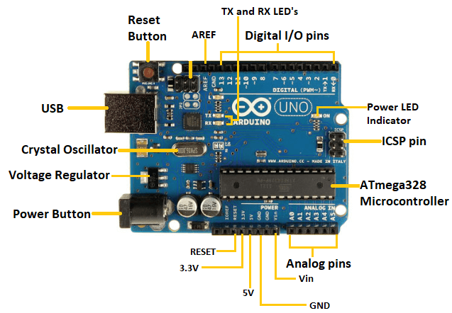

Fig. 1.1: Arduino UNO

Description(LCD Display):

* Comes with a 16x2 Blue&White backlight LCD
* Plug and play with any Arduino 'classic' - UNO, duemilanove, diecimilla, etc as well as Arduino Mega R3.
* Uses only the I2C pins - Analog 4 & 5 on classic Arduinos, Digital 20 and 21 on Arduino Mega R3

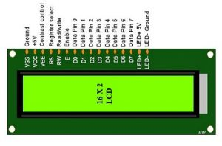

Fig. 1.2: LCD Display (16 X 2)

Description(DHT11 Temparature and Humidity Sensor):

* Operating Voltage: 3.5V to 5.5V
* Operating current: 0.3mA (measuring) 60uA (standby)
* Output: Serial data
* Temperature Range: 0°C to 50°C
* Humidity Range: 20% to 90%
* Resolution: Temperature and Humidity both are 16-bit
* Accuracy: ±1°C and ±1%

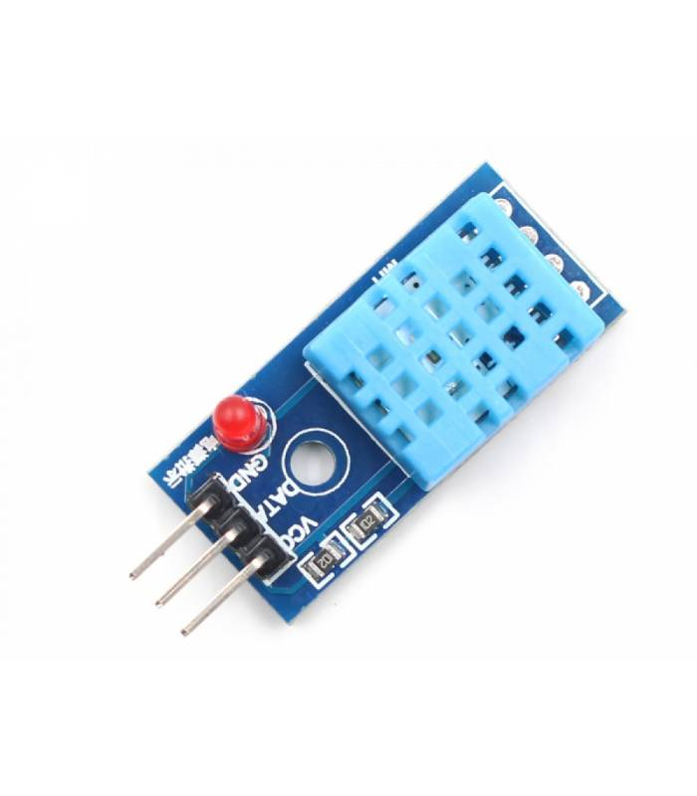

Fig. 1.3: DHT11 Temperature and Humidity Sensor

Description(Micro DC Motor):

* **Operating Voltage**:3V
* **Operating Range:** 2.5 - 3.5 V
* **No Load Speed**: 20500 r/min
* **No Load Current**: 0.057 mA (3V)
* **Stall Torque:** 1.9 gcm
* **Stall Current:** 0.25A (3V)
* **Output:** 0.07W - 0.1W
* **Shaft Diameter:**1mm
* **Shaft Length:**5mm
* **Motor Length:** 16mm
* **Motor Diameter:** 8mm
* **Weight**: 1.6g (Approx)

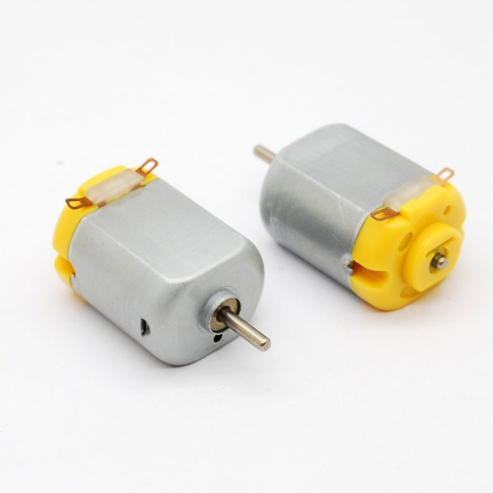

Fig. 1.4: Micro DC Motor

**WORKING PRINCIPLE**

Working principles of Temperature Controlled Air Cooler are given below step by step:

* Circuit Connections: Connect the Arduino UNO, LCD display, DHT11 sensor, and motor to the breadboard using connecting wires. Make sure to follow the proper pin connections specified in the respective component's datasheets.
* Sensor Readings: The DHT11 temperature and humidity sensor measures the ambient temperature and humidity levels. Connect the sensor to the Arduino and program it to read the sensor values.
* Display: Connect the LCD display to the Arduino and program it to display the temperature, fan speed and humidity readings obtained from the DHT11 sensor.
* 4.Temperature Control: Based on the temperature readings, program the Arduino to determine the desired fan speed for temperature control. We define specific temperature thresholds and corresponding fan speeds.
* Motor Control: Connect the micro DC motor to the Arduino using a transistor circuit. The transistor circuit allows the Arduino to control the motor's speed.
* Fan Speed Control: Program the Arduino to adjust the motor speed based on the desired fan speed determined by the temperature readings. We used pulse width modulation (PWM) techniques to vary the motor speed. Higher temperatures trigger faster fan speeds, while lower temperatures reduce the fan speed.

**PSEUDOCODE**

//define pin number & sensor

DHTPIN = 12

PWM=9

DHTTYPE = DHT11

//intiate variables

tempMin = 32

tempMax = 38

//setup

Lcd.init()

Dht.begin()

End setup

loop()

  h = dht.readHumidity()

  t = dht.readTemperature()

  if isnan(h) || isnan(t) || isnan(f) then:

    Serial.println(Failed to read from DHT sensor!)

    Return

End if

    lcd.print(temp: )

  lcd.print(t)

  lcd.print( C)

  if t < tempMin then:

    analogWrite(pwm,0)

    lcd.print(FAN is OFF)

    lcd.clear()

    lcd.print(Humidity: )

    lcd.print(h)

  else if t>=tempMin && t<=tempMax then:

    minsp = 30, maxsp = 100

    unit = (maxsp-minsp)/(tempMax-tempMin)

    fanLCD = 30+(t-tempMin)*unit

    factor = map(t,tempMin,tempMax,30,100)

    fanSpeed=(factor/100)*255

    analogWrite(pwm, fanSpeed)

    lcd.print(Fan speed: )

    lcd.print(fanLCD)

    lcd.clear()

    lcd.print(Humidity: )

    lcd.print(h)

  else if t > tempMax then:

    analogWrite(pwm, 255)

    lcd.print(Fan speed: )

    lcd.print(100%)

    lcd.clear()

    lcd.print(Humidity: )

    lcd.print(h)

end if

end loop()

//end of program

**FLOW CHART**

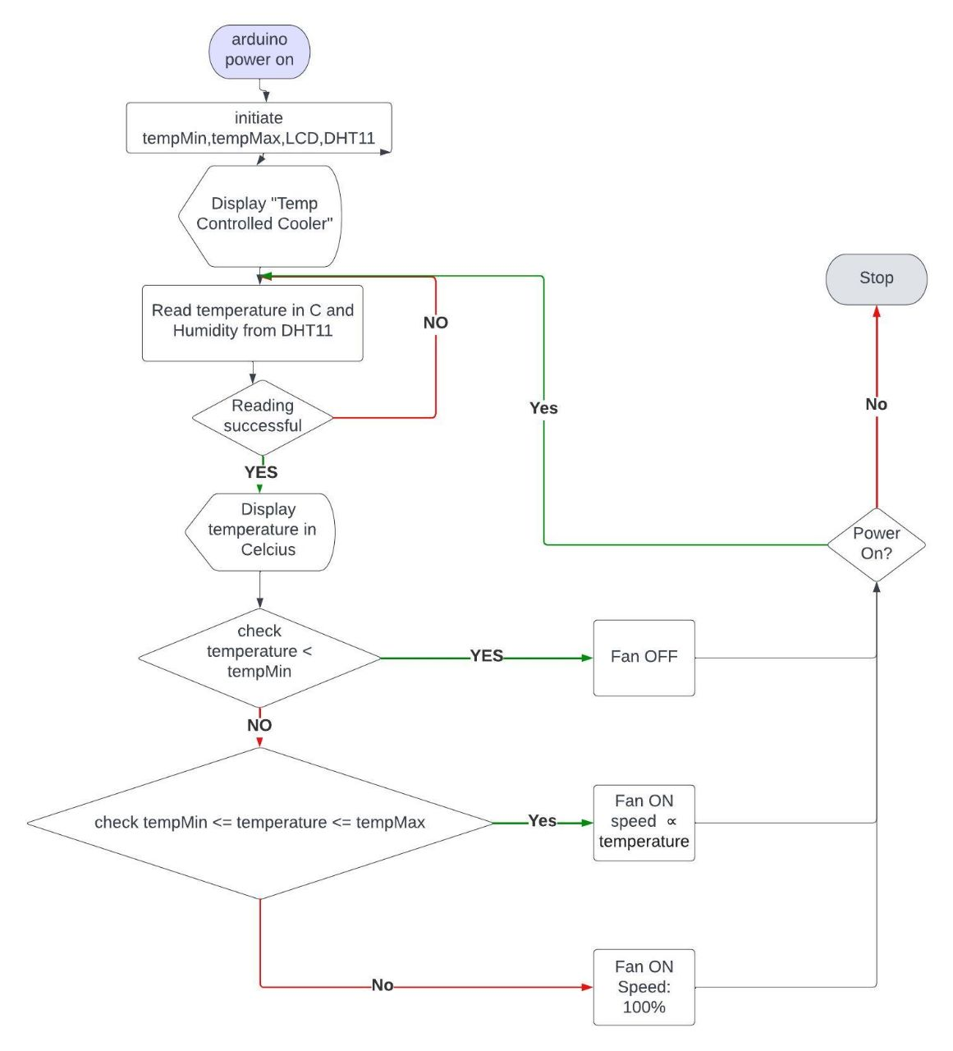

**CIRCUIT DIAGRAM**

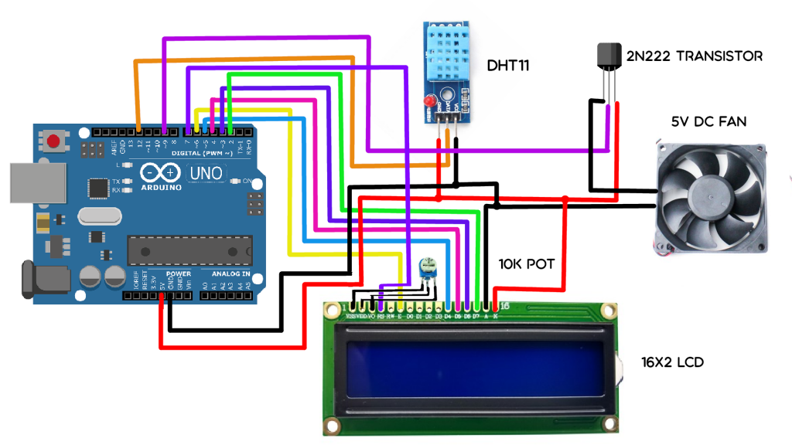

Fig. 1.6: Circuit diagram of temperature controlled air cooler

**PHOTOES**

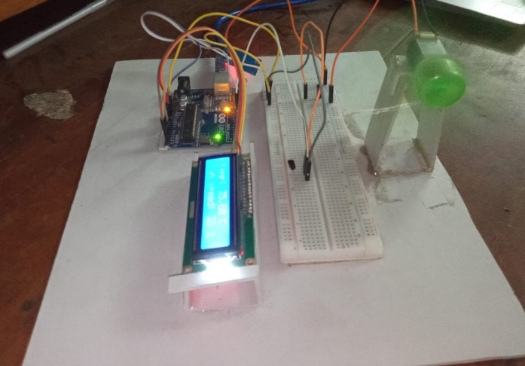 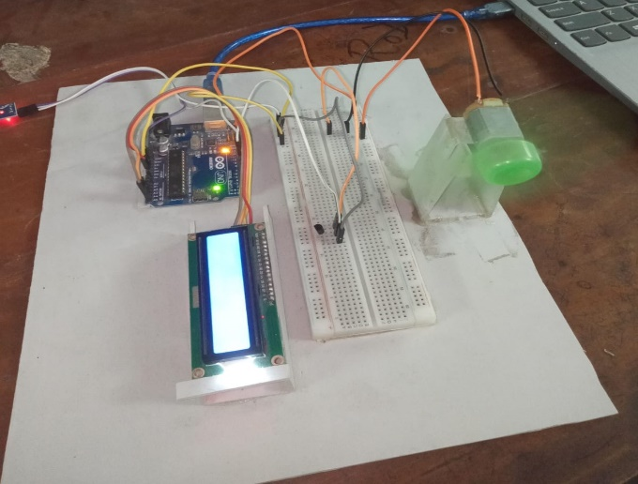

**APPLICATIONS**

* Home Cooling: The temperature control fan can be used in residential spaces to provide automated temperature regulation. It can help maintain a comfortable indoor environment by adjusting the fan speed based on the ambient temperature.
* Office Spaces: Offices often have varying temperature zones due to factors such as sunlight exposure or air conditioning limitations. The temperature control fan can help balance the temperature by automatically adjusting the fan speed in different areas, ensuring a more consistent and comfortable working environment for employees.
* Server Rooms: Temperature control is essential in server rooms to prevent equipment overheating and maintain proper functioning. The temperature control fan can assist in cooling server racks by adjusting the fan speed based on the temperature readings, ensuring optimal operating conditions for the servers.
* Industrial Applications: Industries often require temperature regulation in specific processes or environments. The temperature control fan can be used in manufacturing plants or industrial settings to maintain appropriate temperatures in work areas, equipment rooms, or cooling towers. Etc.

**LIMITATIONS**

Here are few limitations to consider:

* Limited Temperature Range: The DHT11 temperature and humidity sensor has a limited temperature range, typically between 0°C to 50°C (32°F to 122°F). This means that the temperature control fan may not be suitable for environments that exceed this range.
* Accuracy and Precision: The DHT11 sensor has a relatively lower accuracy and precision compared to more advanced sensors. This may result in slight variations or inaccuracies in temperature readings, affecting the precision of temperature control.
* Limited Cooling Capacity: The cooling capacity of a fan, especially a small DC motor-driven fan, is generally lower compared to dedicated cooling systems like air conditioners.
* Limited Control Options: The user can not insert temperature

Manually.

**FUTURE PLAN**

Potential future enhancements or developments of temperature controlled air cooler are :

* Improved Sensor Technology: More advanced temperature and humidity sensors with higher accuracy and precision, expanding the temperature range and improving overall performance.
* Smart Connectivity: Integration with smart home systems that will allow users to control and monitor the temperature control fan remotely through mobile apps or voice assistants.
* Enhanced User Interface: User will be able to insert temperature range manually.

**DISCUSSION**

We successfully completed the project of “temperature controlled fan”. Here the speed of the fan dynamically changes based on the current temperature. The DHT11 sensor reads the temperature and humidity between certain intervals of time. If the sensor fails to read any of the readings error message will be shown in serial monitor for easier error detecting. If the DHT11 sensor successfully reads the current temperature and humidity the temperature will be compared to minimum and maximum temperature. Here three case can be possible.

If the minimum temperature is greater than the current temperature fan will be in OFF mode. Because the surrounding is cold enough if the fan is on, this will be waste of electricity and discomfort. If the temperature is above the threshold temperature the speed of the fan will increase linearly with the concurrent temperature. This reduces the trouble of manually changing the speed of the fan. The fan will start from 30% so that the speed is not too low , all the way up to

100% at the maximum temperature assigned in tempMax. If the temperature crosses tempMax the speed will remain at the max speed. This project will also display the concurrent humidity. So that user can have a more clear idea of the surrounding weather.

**CONCLUSION**

The project is to create a temperature control fan using Arduino UNO, a micro DC motor, an LCD display, a DHT11 temperature and humidity sensor, and other components provides an opportunity to develop a basic but functional cooling system with temperature regulation capabilities.Though there has some limitations. In updated version we will try to overcome these limitations and add some extra features.

Overall, the project serves as a stepping stone for understanding the principles of temperature control and automation while providing a functional cooling solution. It encourages learning, experimentation, and potential improvements in future iterations.